**BUSA 428**

**PROJECT MANAGEMENT**

**Summer-I 2023**

**Texas A&M University-Commerce**

**1. Provide a project objective associated with the Astin Martin Graphics project. Include a list of assumptions about the project.**

**Answer:**

**Project Objective**: The goal of the Astin Martin Graphics project is to create and implement visually captivating graphics that will enhance Astin Martin's brand image and marketing materials. The project is scheduled to commence on May 15 and must be completed no later than November 15. The primary objectives are to meet customer requirements, stay within the allocated budget, and ensure the timely delivery of a high-quality graphics package.

**Assumptions:**

a. It is assumed that the project team members will fulfill their assigned tasks promptly. This includes the software engineer responsible for software development and design, the quality engineer ensuring a reliable project development life cycle, and the system test engineer conducting thorough enterprise-level testing.

b. Management is expected to provide regular and timely reports on the project's progress and key functions to facilitate smooth project execution.

c. The project manager should be prepared to handle unforeseen circumstances and, if necessary, have access to emergency funds to address any unexpected challenges that may arise.

d. It is assumed that all essential resources, such as software tools, design assets, and equipment, will be readily available as needed throughout the project duration.

It is important to acknowledge that assumptions represent anticipated events within the project life cycle and are subject to uncertainty. Therefore, the project plan should incorporate strategies for managing changes and risks to effectively address any deviations from these assumptions.

**2. What is a work breakdown structure? What is a responsibility matrix? Using the Astin Martin project activity list and activity duration schedule, create a WBS and RAM.**

**Answer**: A Work Breakdown Structure (WBS) is a structured breakdown of a project into smaller components, organizing the work required for its completion. It breaks down the project into manageable tasks and sub-tasks, facilitating planning, control, monitoring, reporting, and execution.

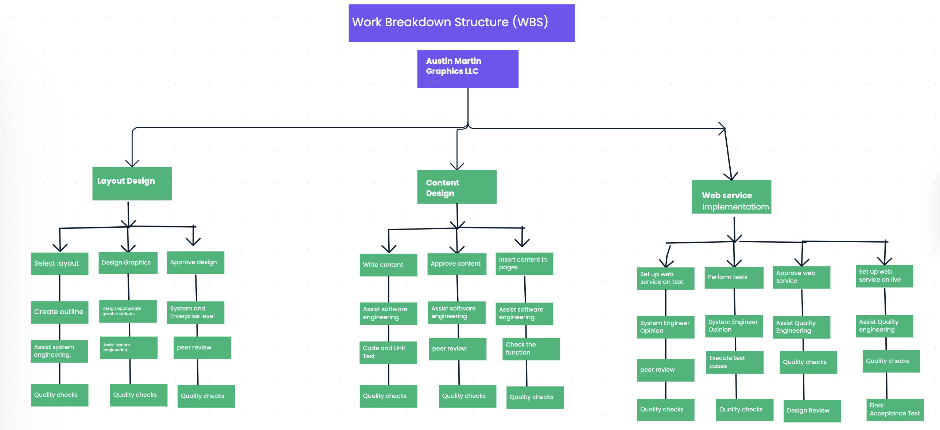A Responsibility Assignment Matrix (RAM), also known as a RACI matrix, outlines the roles and responsibilities of individuals or teams involved in project tasks or deliverables. It clarifies who is responsible, accountable, consulted, and informed for each specific task or deliverable. The RAM promotes effective communication, coordination, and accountability within the project team.

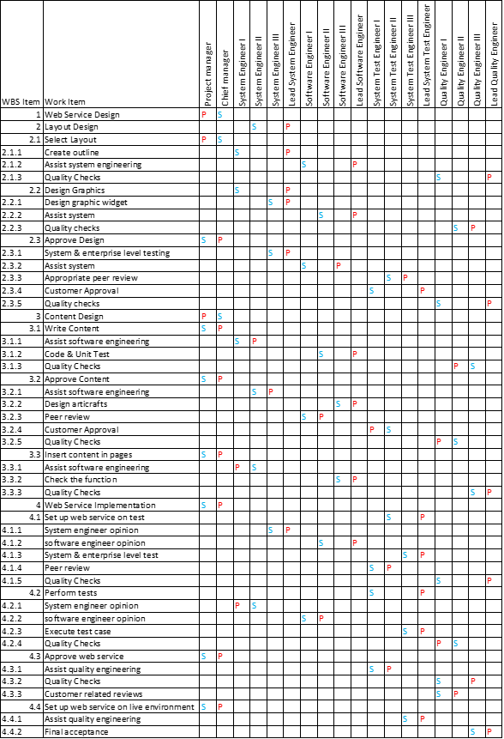

Key: P= Primary Responsibility S=Support Responsibility

**3.Create a network diagram (graphical diagram) that shows the sequence and dependent relationships identified in the Astin Martin project activity list and activity duration schedule.**

**Answer: Also, please see Excel Files more clear view.**

**Network diagram (graphical diagram)**

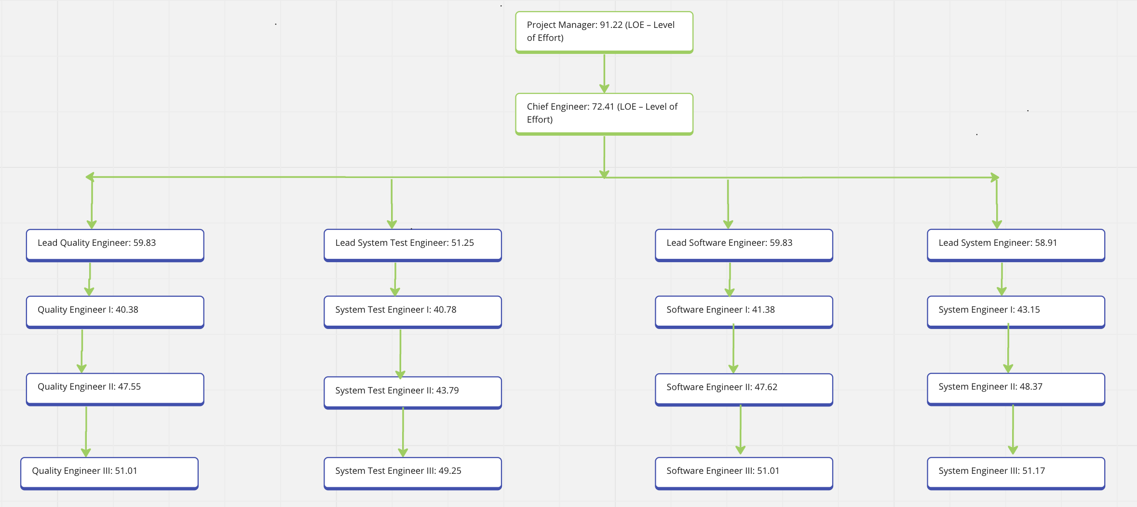

**4. (Major) Using the project start time and the required completion date and the project activity list and activity duration schedule, calculate the ES, EF, LS, and LF times and total slack for each activity. Show results in table form. If your calculations result in a project schedule with negative total slack, revise the project scope, activity estimated durations, and/or sequence or dependent relationships among activities to arrive at an acceptable baseline schedule for completing the project within the required timeline. Describe (including tables) the revisions you made.**

**Answe**r: The ES (Early Start) represents the earliest possible start time for each activity, while the EF (Early Finish) represents the earliest possible finish time. The LS (Late Start) indicates the latest possible start time, and the LF (Late Finish) indicates the latest possible finish time. The Estimated Duration column shows the estimated duration for each activity. The Slack column represents the total slack or float, which is the amount of time an activity can be delayed without delaying the project.

|  |  |  |  |  |  |  |
| --- | --- | --- | --- | --- | --- | --- |
| **Activity** | **ES** | **EF** | **Estimated Duration** | **LS** | **LF** | **Slack** |
| Select Layout | 0 | 10 | 10 | 0 | 10 | 0 |
| Design Graphics | 10 | 30 | 20 | 15 | 35 | 5 |
| Approve Design | 30 | 60 | 30 | 35 | 65 | 5 |
| Write Content | 60 | 75 | 15 | 60 | 75 | 0 |
| Approve Content | 75 | 95 | 20 | 75 | 95 | 0 |
| Insert Content into Page | 95 | 105 | 10 | 100 | 110 | 5 |
| Set up Test Web Service | 105 | 125 | 20 | 110 | 130 | 5 |
| Perform Tests | 125 | 140 | 15 | 135 | 150 | 10 |
| Approve Web Service | 140 | 150 | 10 | 145 | 155 | 5 |
| Go Live | 150 | 155 | 5 | 150 | 155 | 0 |

**5. (Major) List all activity costs. From the project activity list and activity duration schedule, estimate the cost of each activity. Then, determine the Total Budgeted Cost (TBC) for the Astin Martin Graphics project. Provide the information in table format by month. Objective evidence of derived costs is required for credit. Use labor and overhead rates as provided in your derived calculations.**

**Answer: Also, please see Excel Files for more tables.**

-Finance: 7.6% of total hours

- Planning & Scheduling: 6.2% of total hours

- Management (Contracts/Senior Management): 2.1% of total hours

- Facility: 1.3% of total hours

- HR/Staffing: 0.54% of total hours

Overhead total: (Finance + Planning and Scheduling + Management + Facility + HR/Staffing) x Total Hours = (7.6 + 6.2 + 2.1 + 1.3 + 0.54)% x total hours = 17.74% x total hours   
7.6 + 6.2 + 2.1 + 1.3 + 0.54)% x total hours = 17.74% x total hours

Here's an example of how we can calculate the cost for one activity:

Activity: System Engineer II - Design and Development Duration: X hours (not provided)

Labor Cost: System Engineer II rate: $48.37/hour Total hours allocated to System Engineer II for this activity: X hours Labor Cost = $48.37/hour * X hours

Overhead Cost: Overhead Percentage: 17.74% Overhead Cost = Overhead Percentage * (Labor Cost for this activity)

Total Cost for Activity: Total Cost = Labor Cost + Overhead Cost

**Calculating data in table:**

|  |  |  |  |  |  |  |  |  |
| --- | --- | --- | --- | --- | --- | --- | --- | --- |
|  | **June** | **July** | **August** | **September** | **October** | **November** | **Total** | **Cumulative Total** |
| System Engineer II | $10,000 | $12,000 | $8,000 | $10,500 | $9,000 | $11,500 | $61,000 | $61,000 |
| Software Engineer III | $8,500 | $9,500 | $9,000 | $8,000 | $9,500 | $9,000 | $53,500 | $114,500 |
| Lead System Engineer | $6,000 | $6,500 | $7,000 | $6,500 | $7,500 | $6,000 | $39,500 | $154,000 |
| Quality Engineer II | $5,500 | $5,000 | $4,500 | $6,000 | $5,500 | $4,500 | $31,000 | $185,000 |
| Project Manager | $15,000 | $20,000 | $18,000 | $15,000 | $19,000 | $16,000 | $103,000 | $288,000 |
| Chief Engineer | $12,000 | $14,000 | $12,000 | $11,000 | $13,000 | $11,500 | $73,500 | $361,500 |
| Overhead | $10,838 | $13,091 | $8,866 | $11,576 | $9,909 | $12,650 | $66,930 | $428,430 |
| **Total Cost** | **$68,838** | **$80,091** | **$67,366** | **$68,576** | **$74,409** | **$71,150** | **$428,930** |  |
|  |  |  |  |  |  |  |  |  |
| **Activity** | **June** | **July** | **August** | **September** | **October** | **November** | **Total** | **Cumulative Total** |
| Select Layout | $2,000 | $1,500 | 0 | 0 | 0 | 0 | $3,500 | $3,500 |
| Design Graphic | $5,000 | $4,500 | $3,000 | 0 | 0 | 0 | $12,500 | $16,000 |
| Approve Design | 0 | $1,000 | $1,500 | 0 | 0 | 0 | $2,500 | $18,500 |
| Write Content | 0 | $3,000 | $2,500 | 0 | 0 | 0 | $5,500 | $24,000 |
| Insert Content into Page | 0 | 0 | $2,000 | $1,500 | 0 | 0 | $3,500 | $27,500 |
| Set Up Test Web Service | 0 | 0 | 0 | $3,000 | $2,500 | 0 | $5,500 | $33,000 |
| Perform Tests | 0 | 0 | 0 | $2,500 | $2,000 | $1,500 | $6,000 | $39,000 |
| Approve Web Cost | 0 | 0 | 0 | 0 | $1,500 | $2,000 | $3,500 | $42,500 |
| Go Live | 0 | 0 | 0 | 0 |  | $3,000 | $3,000 | $45,500 |
| **Overhead** | $1,241 | $1,774 | $1,598 | $1,241 | $1,065 | $1,152 | $8,071 |  |
| Total Budgeted Cost | $8,241 | $11,774 | $10,598 | $8,241 | $7,065 | $7,652 | $53,571 |  |
|  |  |  |  |  |  |  |  |  |

**6. Provide a cumulative budgeted cost curve for the Astin Martin Graphics project. Provide in appropriate graph format:**

**Answer: Also, Please see Excel Files for more graphs.**

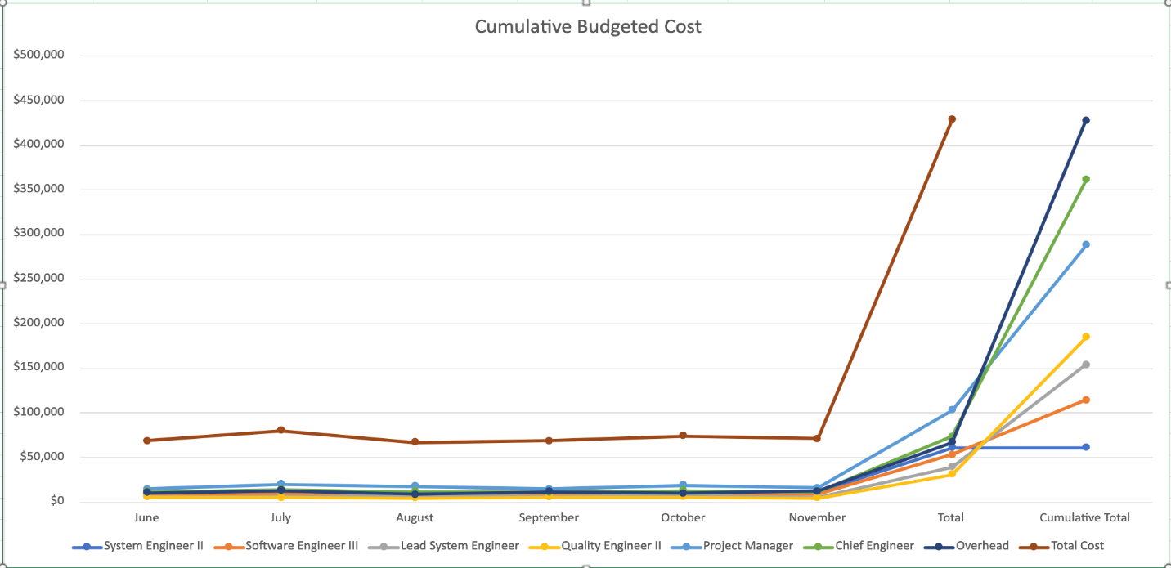

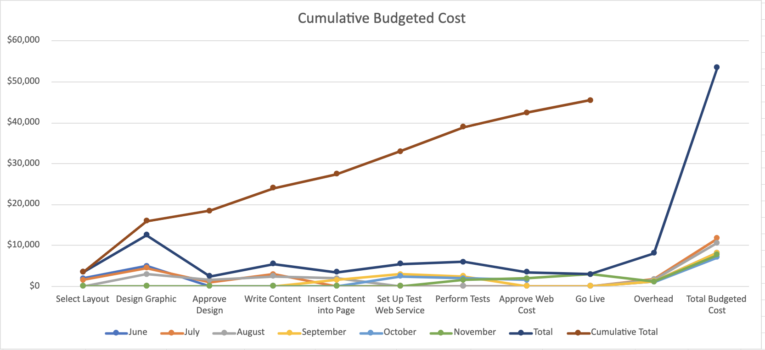

**7. Astin Martin Graphics wants to know if you plan to use a management reserve for their project. Explain what the term reserve means and why you will use contingency reserve in the project or not. Be sure and consider the implications of using or not using the reserve. Provide appropriate detail in your response.**

**Answer:**

Both a management reserve and a contingency reserve will be employed in the Astin Martin Graphics project. The management reserve is set aside at the project's outset to address unforeseen risks, while the contingency reserve is allocated for identified or known risks. The utilization of both reserves allows for effective handling of potential obstacles and ensures smooth project operations. For instance, if there are delays or resource requirements, the contingency reserve can be utilized. Similarly, the management reserve can be tapped if there are customer dissatisfaction issues or changes in project requirements. By utilizing these reserves, the project gains a safety net to mitigate risks and adapt to unforeseen circumstances, ultimately enhancing the overall project management strategy.

8. **Astin Martin Graphics wants to know how JBB Software plans to employ cost management and earned value (EV) in their project. Define to them the following: TBC, CBC, CAC, CEV CPI, CV, FCAC, TCPI. In addition, explain to Astin Martin Graphics why it is necessary to calculate the earned value of work performed and how you plan to execute this task.**

**Answer:**

JBB Software intends to implement cost management and earned value (EV) techniques in the Astin Martin Graphics project. Cost management involves monitoring and controlling expenses, while EV assesses the value of work completed relative to the budgeted cost. Definitions of key terms include:

- TBC (Total Budgeted Cost): Estimated cost for all project activities.

- CBC (Cumulative Budgeted Cost): Budgeted amount for work completed up to a specific time.

- CAC (Cumulative Actual Cost): Total expenditure on completed work.

- CEV (Cumulative Earned Value): Value of work accomplished, calculated by multiplying completion percentage by TBC.

- CPI (Cost Performance Index): Measure of cost efficiency, comparing CEV to CAC.

- CV (Cost Variance): Indicates cost performance, obtained by subtracting CAC from CEV.

- FCAC (Forecasted Cost at Completion): Projected total cost considering actual cost, earned value, and remaining work.

- TCPI (To-Complete Performance Index): Evaluates cost efficiency needed to achieve a target Estimate at Completion (EAC).

Calculating EV is essential to evaluate value attained from the allocated budget. It assists in identifying budget deviations and guides corrective measures. EV is computed by multiplying the percentage of completed work by the TBC. By monitoring and analyzing CEV, CPI, CV, FCAC, and TCPI, JBB Software can effectively manage costs, evaluate project performance, and make informed decisions for successful project execution.

**9. Astin Martin Graphics is concerned about how JBB Software will manage risks. Describe what JBB Software plans to do in order to manage risk on the Astin Martin Graphics project and if a risk assessment matrix will be employed and why. Provide appropriate level of detail in your response.**

**Answer:**

To effectively handle risks in the Astin Martin Graphics project, JBB Software will analyze and evaluate potential risks, with specific attention given to schedule, quality, safety, and business risks. They will take proactive steps to minimize these risks by implementing control measures and conducting comprehensive testing. JBB Software will utilize a risk assessment matrix as a tool to organize and assess the impact and likelihood of identified risks. This matrix will enable Astin Martin Graphics to strategically plan and implement measures that reduce the occurrence and impact of risks, thereby ensuring a more seamless project execution.